Giống nhau: Improve quality and increase profit of organization

|  |  |  |  |  |  |
| --- | --- | --- | --- | --- | --- |
|  | **CMMI** | **ITIL** | **COBIT** | **ISO** | **SIX-SIGMA** |
| **Type** | Framework | Framework | Framework | Standard | Method |
| **Goal** | The framework for implement software product: software development, integration, development and maintenance | The framework for enterprise supply IT service: service management/ operations. | COBIT is a framework help enterprise can achieve IT governance | The Standard for provide systems and processes for effective quality management in businesses. | Improving process: reduce/remove defects, increase cost poor quality. |
| **How to apply** | The company/ organization will use a lot of best practice of CMMI. | The company/ organization has 3 kinds for use ITIL:  1: use ITIL for our organization.  2: Supply ITIL for external organization  3: Employing external organization for supply ITIL for them | The company/ organization will use more Control Objectives, are “guidance,” in that they describe what should be accomplished. | The company/ organization will use more documents of ISO to apply for their goal. | Uses a set of quality management methods, including statistical methods, and creates a special infrastructure of people within the organization |
| **Certificate** | Assessors and organizations will assess CMMI in the company/ organization. | Individual practitioners will deploy and assess it:   * ITIL Foundation Certificate * ITIL Intermediate Certificate * ITIL Expert Certificate * ITIL Master Certificate | Individual practitioners will deploy and assess it: They will pass the annual test of ITIL | Organization, that was being authorized, will assess document. | Individual practitioners will deploy and assess it:   * Master Black Belt * Black Belt * Green Belt * Yellow Belt |
| **How it work** | **Have two type for achieve CMMI:**  **First is Stage**: if you want pass level of CMMI, you will pass more key Process Aria (Ex: pass level 2: 7 KPAs, level 3: 11KPAs)  **Second is continuous**: You can choose one of more KPA and you pass it. You will be achieved the KPA in this level. | ITIL has three kind service:  1: Service Strategy  2: Service Design  3: Service Transaction  4: Continuous service improvement. | Have 5 levels to asses’ process: Non-existent, Initial, Repeatable, Defined, Managed and Optimized.  It use 5 phase :   * Identify Need * Envision Solution * Plan Solution * Implement solution * Operationalize Solution | Use the document of ISO. That is the rule of organization to do right. When you complete all documents (you was successes all rule) and all that is review of ISO organization. You have ISO for your organization. | Have Six levels in Six-Sigma: one Sigma, Two Sigma, Three Sigma, Four Sigma, Five Sigma, Six Sigma.   * Use DMAIC model * Look at the number of defect, organization will know their level. |

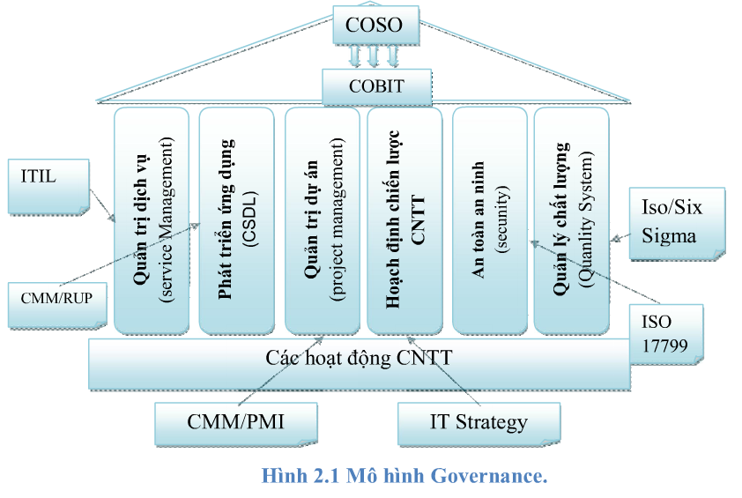

# **Six sigma and lean**

*Ideally you would want both together; it’s a logical fit. However, if you want to have more people doing more things, go with Lean since it is easier to understand than Six Sigma. Lean is about removing waste. You are taking away non-value adding steps and improving flow to achieve better speed with the overall result of getting things done sooner. In a nut shell: reduce lead time and speed will be better.*

*Six Sigma applies additional steps after Lean methodologies have been implemented—now it’s time to reduce the variation.*

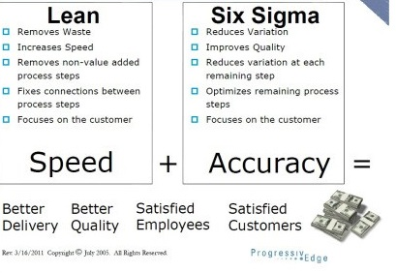

Loại bỏ sự lãng phí

Tăng nhanh tiến độ

Loại bỏ những cái không có giá trị vào các bước quy trình

Giảm sự thay đổi

Giảm sự thay đổi mổi bước còn lại

Tối ưu hóa các bước quy trình

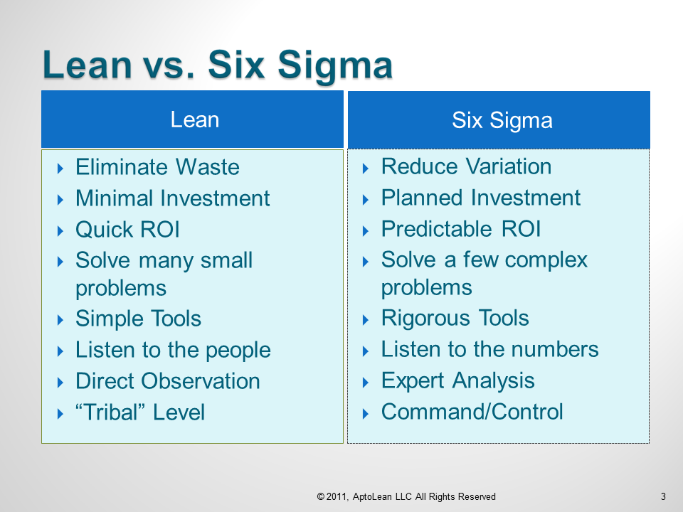

Loại bỏ sự lảng phí.

Đầu tư ít

Quan sát trực tiếp

# **Six sigma and TQM**

TQM, total quality management

   ·Frequently not part of the Business Strategy.

   ·Quality Council did not include Senior Managers.

   ·No bottom line accountability

   ·Re-stripe the parking lot projects.

   Six Sigma

   ·A strategy from the top of the Business Unit

   ·Champions and Senior Management are the Quality Council

   ·Projects frequently have a profitability hurdle

   ·Projects are carefully selected with managers accountable.

Six Sigma is more than just a process improvement program as it is based on concepts that focus on continuous quality improvements for achieving near perfection by restricting the number of possible defects to less than 3.4 defects per million. It is complementary to Statistical Process Control (SPC), which uses statistical methods for monitoring and controlling business processes. Six Sigma, on the other hand, is different as it focuses on taking quality improvement processes to the next level.

The basic difference between Six Sigma and TQM is the approach. While TQM views quality as conformance to internal requirements, Six Sigma focuses on improving quality by reducing the number of defects. The end result may be the same in both the concepts (i.e. producing better quality products). Six Sigma helps organizations in reducing operational costs by focusing on defect reduction, cycle time reduction, and cost savings. It is different from conventional cost cutting measures that may reduce value and quality. It focuses on identifying and eliminating costs that provide no value to customers such as costs incurred due to waste.

TQM initiatives focus on improving individual operations within unrelated business processes where as Six Sigma program focus on improving all the operations within a single business process. Six Sigma projects require the skills of professionals that are certified as ‘black belts’ whereas TQM initiatives are usually a part-time activity that can be managed by non-dedicated managers.

Six sigma is also different from TQM in that it is fact based and data driven, result oriented, providing quantifiable and measurable bottom-line results, linked to strategy and related to customer requirements. Although many tools and techniques used in Six Sigma may appear similar to TQM, they are often distinct as in Six Sigma, the focus is on the strategic and systematic application of the tools on targeted projects at the appropriate time

# **Six sigma and TOC**

**Limitations of TOC and Six Sigma**:

Six Sigma attempts to reduce variation in all the processes in order to achieve overall improvement in system. System interdependencies are not taken into account and processes are improved independently. As a result, there is plethora of potential projects (improvement opportunities) in any system improvement initiative and it can be difficult to identify which ones to tackle first.

Additionally, the propensity to reduce variation in all the processes sometimes make it difficult to identify single or few processes of significant impact; ultimately escalating the budget and time for the overall improvement program.

TOC provides good guideline to identify the constraint or bottleneck but its lack of statistical tools to quantitatively measure and analyze the performance of the process makes this methodology somewhat less effective.

**Harness the Synergy Between Six Sigma and TOC:**

|  |  |
| --- | --- |
| After studying the above limitations it seems both the improvement methodologies are complementary to each other. And if used in conjunction significant amount of synergy can be derived from them. TOC can be used to identify the constraint (process of significant impact) while statistical tools of Six Sigma can be used to quantitatively measure and analysis process performance. In other words TOC will enable an organization to identify where to judiciously launch a Six Sigma based improvement project.  Here are four areas where TOC and Six Sigma could be used in conjunction:  **Opportunity #1:Identify the significant opportunity**  Start with first step of *TOC, identify the constraint* to discover the bottleneck process in the overall system. Once the process of significant impact is identified introduce Six Sigma.*DEFINE* phase of Six Sigma methodology will concentrate only | [http://www.processexcellencenetwork.com/images/article_images/small/AbishekSoni.jpg](javascript:ShowLargerImageWindowName('AbishekSoni','/article_images/large/AbishekSoni.jpg')) |

on the identified constraint or bottleneck process (restricting the overall improvement scope, budget and time) and correspondingly determine the most significant CTQ. Use *MEASURE* phase tools to determine performance standard, collect process data and conduct measurement system analysis.

The most significant improvement opportunity with well defined scope and performance standard is the final deliverable of this phase.

**Opportunity #2: Analyze the Problem**

Use *ANALYZE* phase tools to establish capability of bottleneck process. Leverage tools such as ANOVA, Regression analysis, Pareto, Ishikawa diagram to identify the sources of variations and root cause of the problem. Complement analysis *with TOC step, identifying ways to exploit the constraint* or bottleneck process to its full capacity. This will ensure that existing capacity is utilized without any additional investment.

**Opportunity #3: Develop the Solution**

Generate possible solutions for the problem using various techniques of *IMPROVE* phase such as DOE,poka yoke,pugh matrix,FMEA etc. Bolster the solution with *TOC step; subordinate all the other processes to exploited constraint*. This will ensure that all other processes of the system are aligned with solution identified. If sufficient investment is available proceed with *TOC step to elevate the constraint* i.e. remove the constraint of the system by increasing its capacity.

**Opportunity #4: Verify & Continuously Improve**

Gather feedback on the performance of the new process using *CONTROL* phase tool control charts. Continue the pursuit of excellence and begin with *first step of TOC* to discover new constraint.

[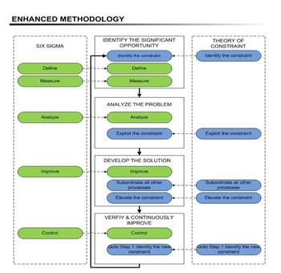](javascript:ShowLargerImageWindowName('ENHANCED_METHODOLOGY','/article_images/large/ENHANCED_METHODOLOGY.JPG'))

<http://ucsandiegoextension.wordpress.com/2013/02/20/six-sigma-lean-bringing-speed-accuracy-to-business-processes/>

<http://www.aptoblog.com/2011/six-sigma-vs-lean-%E2%80%9Ctastes-great%E2%80%9D-or-%E2%80%9Cless-filling%E2%80%9D/08>

<http://www.sixsigmaonline.org/six-sigma-training-certification-information/articles/six-sigma-vs-total-quality-management.html>